Patagonia’s Marketing Objectives and Strategy

Marketplace – Products

Patagonia is an outdoor clothing and gear company, producing clothes mainly for skiing, surfing, climbing, trail running or snowboarding disciplines. It is ranked #2239 in the United States for outdoor clothing, and #7958 worldwide (Statista, 2019). Patagonia’s main marketplace is United States (69.84% of all purchases), followed by United Kingdom (6.47%) and Germany (4.05%) (SimilarWeb, 2020). Patagonia offers high-quality, designed to last outdoor clothing which is known for its environmental sustainability. The marketing strategy used by the company is promoting used clothing and urging customers to think twice before buying a new product (Hiebert, 2017). This is a unique marketing strategy which sets Patagonia apart from its competitors. The company applies the reverse psychology marketing technique, which although seems like an anti-marketing, it increases the company’s revenues. As their products are designed to last, the advertising strategy reaffirms the fact that consumers can purchase used clothing without sacrificing on quality.

Marketing Strategies

In addition, Patagonia started to provide credits for consumers for submitting used clothing. As a result, Patagonia saw an increase in its ecommerce revenues by 55.6% since 2015, making it $396.9, and in 2017 the company reached $1 billion in sales (Statista, 2019). In the last six months, Patagonia.com was visited 5.19 million times, with an increase in August and September (SimilarWeb, 2020). This is likely due to the promotions that normally take place in the summer. The company is known to be active on the political and environmental fronts which fits well with the company’s client base, who typically are environmentally conscious and active in the environmental issues, which improves the company’s image as more environmentally conscious (Hiebert, 2017). Patagonia’s products are recycled and ‘Fair Trade’ certified, organic, and the company uses solar energy at its headquarters base in California (Craft.co). The company’s ultimate promise to its client base is the reduction of its environmental footprint. Patagonia recently introduced an initiative where it sends out an environmentally friendly truck across the United States (Patagonia’s main client base) and offers to repair the customers’ outdoor gear (Craft.co).

Competitors

Patagonia’s main competitors are Arc’teryx, North Face, Columbia Sportswear, Canada Goose, and Burton (Statista, 2019). These are identified as the main competitors due to the location of the main customer base (United States), similarity of values (environment and sustainability) and similarity of products offered. Although Patagonia was founded in 1973, which is relatively recent compared to 1950 for Amer Sports and 1938 for Columbia Sportswear, it is still performing similarly in terms of revenue. For instance, Patagonia’s yearly revenue is estimated at $1billion at 2240 employees, Farfetch’s yearly revenue is also estimated at $1billion at 4532 employees (SimilarWeb, 2020). Moreover, Patagonia’s main marketplace is United States, whereas Amer Sports is based in countries such as the United States, Canada and Australia. Similarly, Farfetch’s main client base are in the Unites States, United Kingdom, Brazil, Hong Kong and Tokyo (SimilarWeb, 2020). Despite this, Patagonia is performing similarly in terms of yearly revenue. However, although Patagonia experienced $500 million increase in revenue from 2014 to 2018, its competitor Columbia Sportswear experienced $600 million increase in revenue from 2017 to 2020, and Farfetch experienced an increase by $750million between 2017 and 2020 (Statista, 2019). Arguably, Patagonia wasn’t increasing its revenue as rapidly as its competitors, but this can be because Patagonia’s main marketplace is United States, which prevents it from increasing its revenues as rapidly.

Buyers and Users

Patagonia’s client base are active, outdoorsy, environmentally conscious individuals. These are conscious buyers who resonate with Patagonia’s goal to be more environmentally friendly, who enjoy quality products that last for many years, enjoy very active lifestyles which include outdoor sports, and are usually aged between 18-35, both male and female (Hiebert, 2017). As Patagonia’s product pricing lands on the mid- to high range, the company’s consumers are likely to have a reasonable disposable income. It is estimated that over 22% of their consumers earn between $20,000 to $39,000, 29% earn between $40,000 to $69,000, 25% earns $70,000 or more (Hiebert, 2017). Patagonia’s client base is very loyal, and clients tend to buy different items on a regular basis. Patagonia attracts mainly conscientious customers. According to the market analysis, 69% of the company’s clients like to know where their products come from and whether it was produced organically. In addition, 67% of Patagonia’s clients prefer to decrease driving to help save the environment, and 54% of their clients always shop for fair trade clothes (Craft.co). Data shows that Patagonia’s clients are based mainly in suburbs or in the city, making it the main demographic for the company (Craft.co). Analysis shows that Patagonia’s clients don’t mind spending. Recent survey found that only 43% of Patagonia’s clients restrict themselves with a budget, which is true for 58% of the US population (Hiebert, 2017).

Segmentation

Patagonia’s core values are sustainability and giving back to society, Patagonia targets outdoor enthusiast and environmentally conscious people. They have positioned themselves to appeal to people who reject fast fashion and “wear and dispose” mindset of consumerism. Key distinguishers which their consumers value are products extensible, considering functionality, financial, durability and environmental aspects of the product before evaluating purchase alternatives. The role personality plays in selecting a brand is of importance, for Patagonia image of pro-environmental consciousness, ruggedness, cognition, and sincerity plays the key role. Based upon the outlook the current behavior patterns the group of end users can be clubbed as below:
Segmentation: Lifestyles of Health and Sustainability (LOHAS) (Ethos, 2017) focused group, this is the people who follow natural lifestyles, eco-tourism and follow environmental consciousness to the core while making purchasing choices. This group of people care deeply about the claims firm make about all natural or processing techniques. “Patagonia used this insight to develop their “Footprint Chronicles” – an online resource that provides details about the eco-footprint and legacy of Patagonia products” (Ethos, 2017)
The LOHAS market segment is large market, “representing one in four adult Americans and an estimated $290 billion in U.S. spending power for goods and services.” (Ethos, 2017)
“By referring to Claritas Prizm segmentation, the target based upon customer purchasing power, the behaviors can be identified as Urban (U) Social Groups have population density centiles mostly between 85 and 99. They include both the downtown areas of major cities and surrounding neighborhoods. Households in this classification live within the classic high-density neighborhoods found in the heart of the cities: Urban Uptowns with below Prizm sub-categorization
04 Young Digerati
07 Money & Brains
19 American Dreams
21 The Cosmopolitans” (Claritas, 2020)

Position in the Market

Patagonia’s position against its competitors is quite strong. They are in a strong position due to its loyal consumers, purpose-driven strategies, strong philosophy, eco-friendliness, excellent marketing and excellent reputation as a company that is sustainable and ecological. For instance, Patagonia donated $10 million in 2018 from its profits towards community-based environmental projects and activities (Roper, 2020). However, Patagonia suffers from weak-ecommerce and struggles to increase its sales to the same levels that its competitors achieved. Particularly during the pandemic, it would be expected to see an increase in sales of Patagonia as consumers are choosing online shopping as their main method of purchasing goods (Roper, 2020). As discussed earlier, Patagonia’s primary market is the US, with only 37 stores spread across 50 states, and only 2 in Canada (SimilarWeb, 2020). Targeting colder climates such as Canada would strengthen Patagonia’s position in the market and expand its client base substantially. Clients in Canada are more likely to go to Patagonia’s competitors as there isn’t a store near them. As a result, Patagonia is very dependent on the US market, making it more exposed to the potential vulnerabilities of the market, such as an economic crash.

Patagonia’s Brand Objectives

Patagonia focuses its brand on manufacturing quality and environmentally conscious high end outdoor apparel. The objective of the brand is to stay innovative and target the consumers who engage in outdoor activities and because they participate in these activities, they are protective of the environment. The company does not allocate a large amount of money towards their marketing compared to competitors such as The North Face, Columbia, Timberland, Marmot Mountain Ltd, Mountain Hardware, ARC’TERYX.

Patagonia does not spend as much as its competitors do on marketing, nor does the company fixate on marketing its products, it rather focuses on marketing the lifestyle associated with the brand. This is simply seen through visiting the brands website, where although there is an online store, there is also a large community aspect to it, where people can discuss their activities, bring attention to certain activist campaigns. Through educating the customers about not just the product, but also the morals and values behind the product, the customers are ultimately willing to pay more for Patagonia’s products.

Refer to the company’s website and reference their mission statement and their vision.

What makes Patagonia Unique?
Category | Point of Difference | Point of Parity
Product | Sell apparel and outdoor gear for various sports activities, including snow sports, surfing, mountain biking, trail running, fly fishing, kitesurfing, and climbing. | Similar designs and functions.
Service | Use ethically sourced materials, and strong emphasis on heavily recycled materials.  Great emphasize on their contribution to preservation of the planet by extracting 1% of revenue and pledging it to environmental groups to make a difference. | Fleece and down materials used in the materials for their apparel.
Place  Channel | Very select retailers that target outdoor sports only, with a few flagship stores, and online. | Sport retailers as well as online.
People  (Consumer) | Highly environmentally conscious and outdoorsy. Care about environmental footprint and do not mind paying extra to support Patagonia’s mission. | Seeking technical equipment, outdoorsy but look for a deal. Some who look for fashion appeal.
Image | Bright vibrant colours, and highly lowkey logo placed on clothing. Anti-pollution and environmentally conscious; very liberal. | Stylish or very technical. Try to appeal to many types of consumers.
Promotion | Do not allocate much towards marketing. Focus on allocating portion of proceeds towards grants for environmental studies. Supports unique grassroot events; supports smaller guys. | Online promotion, celebrity collaborations, and online advertisements.

SWOT Analysis:

In order to analyze the Patagonia’s brand as compared to its competition SWOT analysis was conducted as below:
Strengths:
- Strong brand presence & Cause based strategy: prioritising environment over profitability it has gained a string brand value with cause driven strategy and positioning in mind of the consumers. Often seen giving back to the society, in 2018, donated $10 million to community-based environmental groups
- Emphasis on quality: They promote the concept of buy less, buy quality making them stand out from competitors
- Sustainable consumption of resources: ethical business practices providing transparent profiling and techniques on public platform. They are managing their resources responsibly
- Loyal customer base: People who associate with the brand do as they identify themselves adding to a cause they believe and the trust strongly in the brand

Weakness:
- Weak customer reach: low online channel sales is a cause for concern. Competition is doing way better in the online sector. Patagonia have few online payment methods acting as one of the hinderances. (Statstica, 2018)
Patagonia.com sells its products through only one additional channel which is brick & mortar stores. No other channels like mail, catalog or marketplace used for increasing sales (Statstica, 2018)
- Heavy reliance on US markets: 92% of net sales via patagonia.com are generated in
the United States (Statstica, 2018)
- Marketing focus: Patagonia’s Vice President of Marketing admitted that advertising is not a priority. For a billion dollar compnay, they spend minimal on marketing
Opportunities:
- Focus strategy on creating online presence: outdoor apparel enthusiasts prefer to shop online more, which gives Patagonia room to grow
- Expand globally: Can try and expand to other geographies other than North America and use its core competencies to excel
- Increase market presence: open small to medium size stores in more locations, currently they have 37 stores scattered across around 20 states in the US and 2 stores in Canada
- Product line extension: Innovative product line such as gear and equipment

Threats:
- Increasing Competition: With amazon, Walmart, Alibaba eCommerce on the rise providing online options, easy fulfilment poses threat to established retail brands
- Future of retail: Pandemic situation forces many retail stores to close and operational restrictions created massive losses for the brand
- Change of behavioural patterns: decline in spending capacity across countries and reduction in expenditure on non-essentials like outdoor offerings.

Perceptual Map:

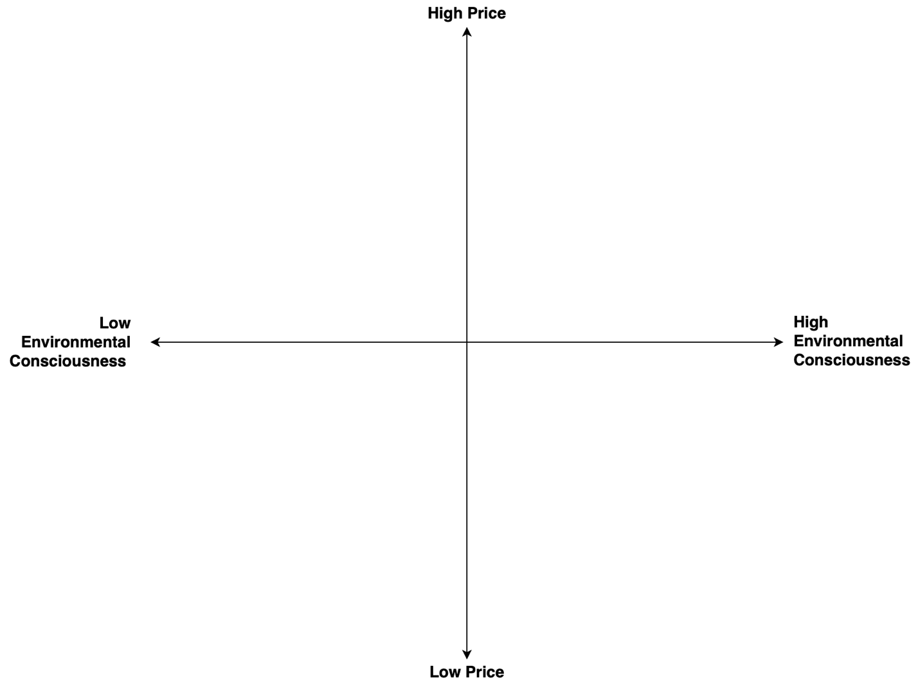
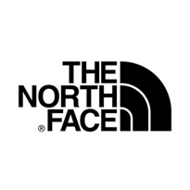
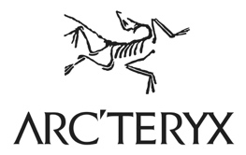
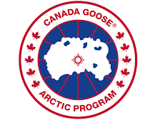
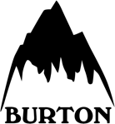
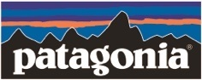
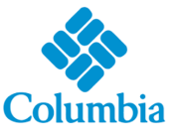

References
Craft.co. ‘’Patagonia Report.’’ Retrieved from: https://craft.co/patagonia
Hiebert, P. (2017) A Look at the Type of Person Who Shops at Patagonia. YouGov. Retrieved from: https://today.yougov.com/topics/consumer/articles-reports/2017/07/10/the-type-of-person-who-shops-at-patagonia
Roper, W. (2020). COVID Accelerates Declining Retail Industry. Statista. Retrieved from: https://www.statista.com/chart/21764/declining-retail-industry/
SimilarWeb (2020) Patagonia.com – October 2020 Review. Retrieved from: https://www.similarweb.com/website/patagonia.com/
Statista (2019) ‘’Patagonia.com Store Analysis 2019.’’ ecommerceDB.com Retrieved from: https://www.statista.com/study/65902/patagoniacom-store-analysis/

Patagonia’s Activities in Marketing

Product

Patagonia is known for their environmental sustainability efforts. The company donates hundreds of millions of dollars and 1% of their net revenues in cash to grassroots environmental non-profits. However, the company is against using its environmental position as a marketing tool to increase consumption. Rather, the company uses informative messaging through its social media platform and print media to raise awareness about environmental issues facing their company and the retail industry as a whole.

In 2011, the company ran an advertisement during the Thanksgiving season that read “Don’t Buy This Jacket,” which highlighted the environmental cost of the company’s best-selling fleece jackets, asked consumers to reconsider before buying the product, and opt for a used Patagonia product. Despite their efforts, the company saw its revenues grow by about 30% to $543 million in 2012, followed by a 5% in 2013 and by 2017, the company had reached $1 billion in sales. This campaign embodies Patagonia’s paradoxical marketing strategy, which encourages customers to limit their consumption of to only essential products and choose responsibly sourced products.

Distribution Channels

In the United States and international markets, Patagonia pursued a multi-channel distribution strategy. Their products and services were offered through wholesale, retail, catalogue, and online. The wholesale and direct channels sold nearly 100% of the product line, while the retail channel offered approximately 80%.

Patagonia’s choice of business partners is driven by values and the company holds its suppliers to its own standard of quality and social and environmental responsibility. They have significantly trimmed down their number of suppliers and outsourced 85% of their manufacturing to outside of the United States. Suppliers ship the products to a distribution centre in Reno Nevada, where the products are packaged and shipped to various locations.

E-commerce has become a major distribution channel for the retail industry in recent year, including Patagonia. Their website, patagonia.com, has outpaced the overall growth of the company from 2015-2018. Patagonia’s net online sales experienced a 14.6% average growth rate during that period and generated approximately $1.13 Billion in net sales. (Check 5)

Price

Patagonia competes in the high-end outdoor apparel industry under a premium brand strategy. Their prices are benchmarked to their competitors such as The North Face Inc., Marmot Mountain Ltd., Columbia Sportswear, etc… with an additional 15-30% premium (see Appendix). Patagonia products are designed to be simple, functional, and multifunctional. As a result, their products have a longer useful life and are used for different activities. This combined with their leading reputation as an environmentally conscious business provides them with leverage to charge a premium for their product.

Marketing Communication

Patagonia allocates significantly a smaller number of resources to marketing and advertising than their retail apparel competitors. Patagonia considers its sales channel and social media presence as a platform to communicate its vision to the public. As such, many of its advertising incorporates educational messages for its suppliers, consumers, and staff. Patagonia’s environmental position, reputation, and unique advertising style also makes regular headlines which attracts free publicity from the press and attention from media and the public.

One of Patagonia’s strengths in their ecommerce platform which has seen great consumer engagement over the past years. Their online sales have outpaced their overall growth for the business. In 2018, the patagonia.com experienced a growth rate 12.8% and generated --- M in revenue.

Customer Service

Patagonia offers an Ironclad Guarantee to repair, refund, and replace any product that did not meet the customer’s satisfaction. Most competitors offer a similar guarantee, but none repaired products, which costs Patagonia approximately $300,000 annually.

In 2017, the company introduced its Worn Wear website, where customers can trade in their old and used Patagonia merchandise for cash and store credit. The used merchandise is then cleaned, repaired, and sold on the Patagonia Worn Wear website. These initiatives increase customer engagement and further promotes the brand’s objectives and mission to help solve the environmental crisis and maintain a sustainable business model.

2 Academic sources

The North Face Patagonia Columbia Sportswear

